​​BENN MITCHELL: Works from 1940’s & 50’s
ONLINE EXHIBITION: February 15- March 6, 2021

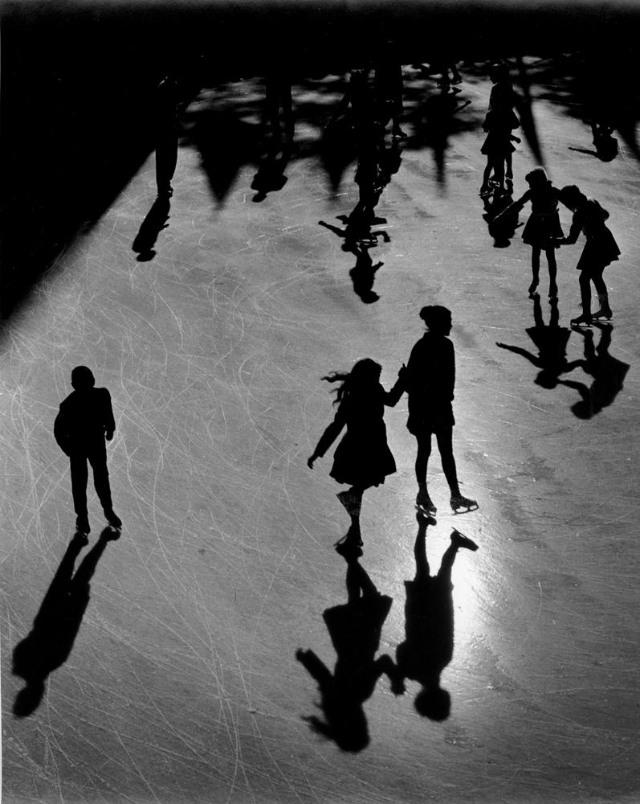
As the snow begins to melt and there is the faintest breath of spring in the air, we have all begun to collectively exhale: we are moving through this time. We are and have always been a New York gallery, a New York family. The toll that this past year has taken on our city and our lives is something we now live with. But we are not the first to walk a tenuous path, as art lovers we can look to our very own for evidence of the strength of the city we love and all of its eternal qualities. This is ever present in the work of Benn Mitchell. These images gather for us the city that holds us and the poetry we have built our lives upon that dwells on every street corner revealing to us who we are and who we always have been.
Forever New York, a love letter.

Benn Mitchell (b.1926, New York City) from the age of 13 when he received his first camera, has been producing photographs that capture a particularly American vitality. Born in New York City, he sold his first photograph to Life magazine when he was 16. At the age of 17 he headed west, gaining permission from Warner Brothers to frequent the studios shooting the Hollywood stars on the various sets and sound stages. One of his most valued photographs is one of Humphrey Bogart.
After two years of duty as a navy photographer, he returned to New York City and was employed in a large commercial studio. In 1951 he started his own commercial studio in New York City.
During the weekends and holidays he continued to photograph for his own satisfaction and has won many awards both domestic and international. He was been published in many photo annuals and today his work appears in Fortune 500 companies, and all over the world in advertising, books and major magazines. Collectors buy his fine art photographs.
For press and other inquiries, please email: info@benrubigallery.com

